Week 2 Group Work

Members. Sachin Kurremula, Tharun Venkata Sainath, Sai Simha Venkata Prasad Ravula, Bhanu Prakash Chimmiri & Sri Poojitha Bollu

IST 7060

Wilmington University

**Chapter 4 Task 1-Ravula**

**To:** The Management

**From:** Ravula

**Cc:**

**Date:** Nov 19, 2023

**Re:** Initial assessment of different projects

Below shows the initial assessment for the four projects that we want to promote. The below table shows the analysis, strategies, financial and other benefits.

|  |  |  |  |  |
| --- | --- | --- | --- | --- |
| **S.No.** | **Project Names** | **Business Strategies** | **Potential financial benefits and others** | **Initial assessment** |
| 1. | Global Treps | To convey their ideas, they create mobile-friendly websites and applications. The templates and guidelines are provided by them. They welcome fresh ideas and donations from possible investors, as well as providing a web-based version of the events through videos. | Allowing innovative product and service concepts to flourish can attract potential investors, resulting in financial gains. | I believe that this concept will allow many individuals and college students to start their own businesses and become entrepreneurs. |
| 2. | Change the Laws Campaign | Reduces income disparity and promotes social responsibility by informing citizens about existing laws and suggesting new ones. | The debate over income inequality laws will aid low-income individuals in fighting for their rights and improving their financial situation. | This project is a fantastic way to assist persons and make them aware of their rights. |
| 3. | Wealthy Unite | An information is provided about the inspiring people. Creates a system with their input. | Individuals can be inspired by people like Bill Gates, Warren Buffet, and others. Allows for donations and aids in the reduction of economic inequalities. | This project will be a success if inspirational people participate in this website as well. |
| 4. | Global Smart Shoppers | Develops and promotes socially responsible products and services through their website and mobile application. | Product sales will improve for firms who propose the goal of decreasing inequality. Small businesses can work with their current networks to increase sales and generate money. | This is an interesting project. It encourages social responsibility and educates individuals about disparities. |

Each project is distinct, with its own set of aims and objectives. Every initiative is a fortune of ideas that will help the organization achieve its strategic goals by reducing income disparities. The Global Treps plan to accomplish this by creating a stage like Shark Tank that is more engaging in nature while also pursuing the organization’s goal. It also enables business executives to remove many instructive and profitable ideas through mobile and web applications. It also allows different organizations that want to contribute to the decrease of global economic inequality and monetary imbalance to use their designs and ideas, which is a quantifiable component of this concept. While other ideas, such as the Change of Laws campaign, Wealthy Unite, and Global Smart Shoppers, contribute to the program in the same way as the Global Treps, they each have their own set of drawbacks when compared to the Global Treps. Changes in the law are limited to the minimum wage for the public. The same is true for Wealthy Unite and Global Brilliant Customer, whichh are largely limited to obtaining ideas from presently successful people. As a result, it is prudent to place a higher emphasis on the Global Treps for the organization to achieve its goal.

Thanks,

Ravula

**Chapter 4 Task 2- Kurremula**

**Chapter 4, Task 2**

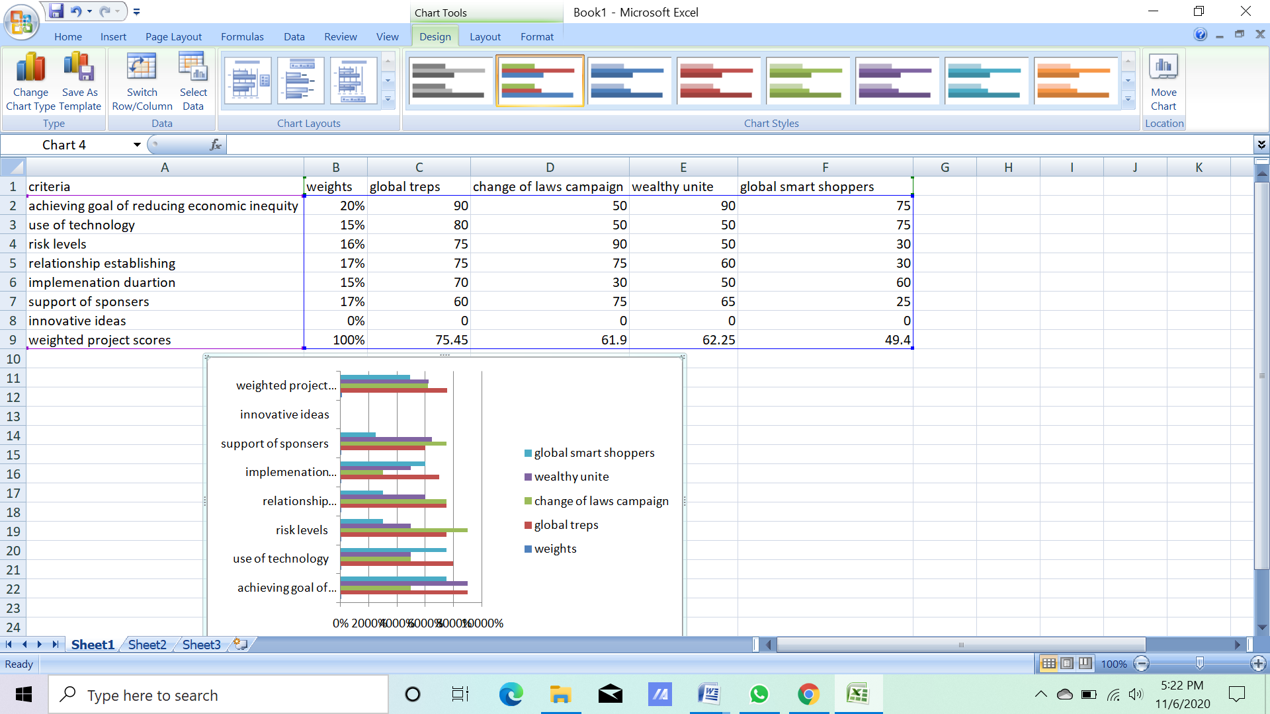

**Chapter 4 Task 3-Tellabati**

**Project Name:** Global Treps

|  |
| --- |
| 1. **Introduction/ Background:** The group of students from one of the colleges had decided to work together to make the world a better place where all types of people can live happily whether it is rich or poor.To make their plan happen they decided to create one of the projects named Global treps. |
| 1. **Business Objective:** It states how the group of students is planning to make their project successful. They plan to host the shows like the shark tanks so that they can be able toattract more entrepreneurs to the project. |
| 1. **Current Situation and Problem/Opportunity Statement:** The opportunity statement is the plan which has been decided by the project team is going to be successful as they have done the proper planning with the research. |
| **4.0 Critical Assumption and Constraints:** The critical assumptions about the project are that planning for the website and the mobile application and good technical skills between the student to form the good mobile application and the websites. |
| **5.0 Analysis of Options and Recommendations:** The concept of the analysis is highly essential for the Global treps project team asit helps providegood decisions to the organizations. |
| **6.0 Preliminary Project Requirements:** The project requirements areresearch about the benefits of the mobile application and the website design in the project and the next one isabout planning for the different tasks which need to be done in the project. |
| **7.0 Budget Estimate and Financial Analysis:** The final budget comes to around $130,000 after the collection of the price for each of the project activities. |
| **8.0 Schedule Estimation:** As the team had decided, the project will take around 1 year to complete the project. |
| **9.0 Potential Risks:** Hardware or software failures, communication failures, and many more different potential risks are present. |
| **10.0 Exhibits**  Exhibit A: Financial Analysis |

**Chapter 4 Task 4-Chimmiri**

Task4- Project Charter of Global Traps Project

Mar 19, 2023

|  |  |  |  |
| --- | --- | --- | --- |
| **Project Title**: Grassroots Group – Global Treps | | | |
| **Project Start Date: Nov 19, 2023 Projected Finish Date: May 1st, 2024** | | | |
| **Budget Information: $13000** | | | |
| **Project Manager:** Ravula | | | |
| **Project Objectives:**  The primary objective of the Global Trap project is to reduce inequality in society with the help of the project. | | | |
| **Success Criteria:**  Well-developed business and marketing strategies.  Well secured and designed mobile applications and websites. | | | |
| **Approach:**  The team had a good approach and the strategies to make the project successful and to set the benchmark in society. | | | |
| **Roles and Responsibilities** | | | |
| ***Name and Signature*** | ***Role*** | ***Position*** | ***Contact Information*** |
| Dr K | Manager | Management position |  |
|  |  |  |  |
|  |  |  |  |
| Rohith | Developer | Sr. Software Engineer | Radulra |
|  | | | |
| **Comments:** (Handwritten or typed comments from above stakeholders, if applicable) | | | |

**Chapter 4 Task 6- Bollu**

**Project Name:** Global Treps

**Date Request Submitted: 03/19/2023**

**Title of Change Request:** To add the option named Voice call in the mobile application Graphical User Interface.

**Change Order Number: 8788990**

**Submitted by**: Pujitha

# Change Category: Scope Schedule Cost Technology Other

**Description of change requested:** The addition of the voice call is helpful to the project team and the donors to make a call and communicate their queries related to the global treps project.

**Events that made this change necessary or desirable:** The changes are necessary to increase the number of donors just only with the help of voice communication.

**Justification for the change/why it is needed/desired to continue/complete the project:** The change in the GUI is justified as instead of messaging the person can direct have the call interactions with the project team.

**Impact of the proposed change on:**

**Scope: No change in scope.**

**Schedule:** It will take at least 10 to 15 days to make changes.

**Cost**: $1000

**Staffing**: Around 2 to 3 team members are required to work on the change.

**Risk**: No risks.

**Suggested implementation if the change request is approved**

**Required approvals:**

|  |  |  |
| --- | --- | --- |
| **Name/Title** | **Date** | **Approve/Reject** |
| Dr. K | 7/03/2023 | Approve |
| Bhavana Ganji | 8/03/2023 | Approve |
| Ashok | 8/03/2023 | Reject |
| Bobby | 8/03/2023 | Reject |
| Kim | 8/03/2023 | Approve |
| Alfreda | 8/03/2023 | Approve |